Step 1

Go to http://www.wireless.att.com and look for “check for discounts” option at the bottom of the screen and click “learn more”.

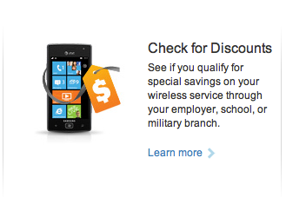

You will see a screen that looks like the one below. In the See if you qualify text box, type your @southern.edu email address and click Submit.

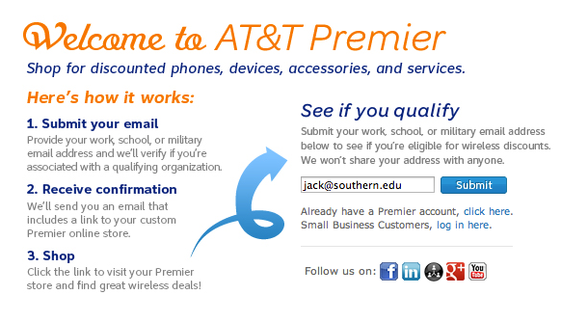

After submitting you will see the following screen:

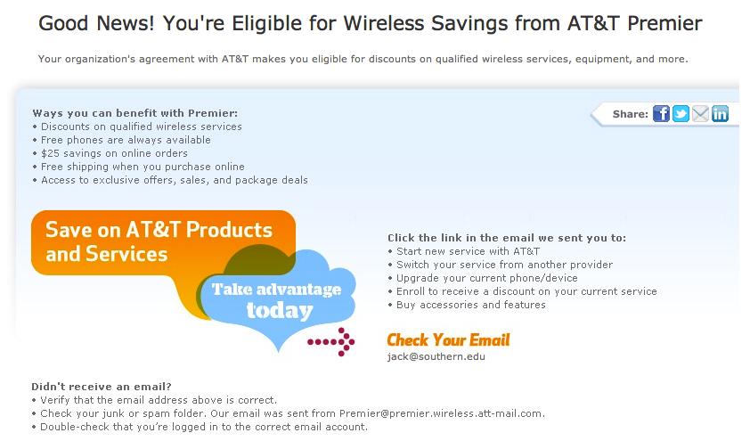

Step 2

You will receive a confirmation email. Please click on the “Start now” blue button
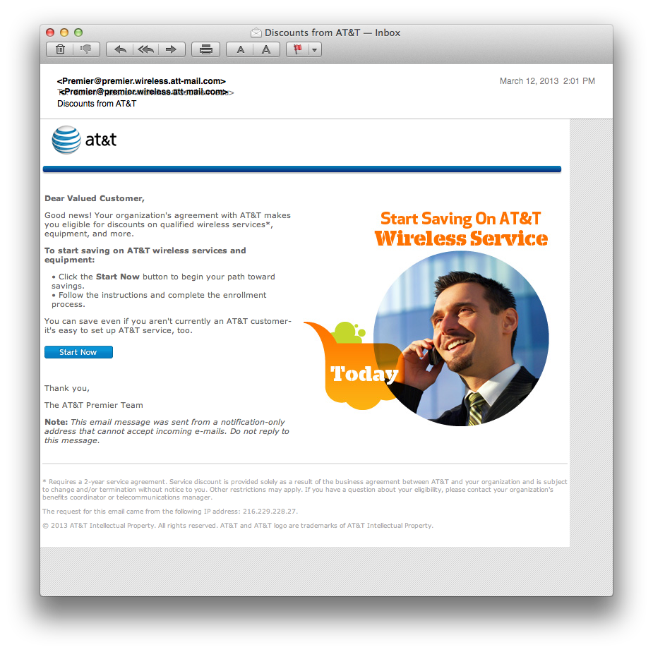

Step 3
Fill in the information displayed on the screen:
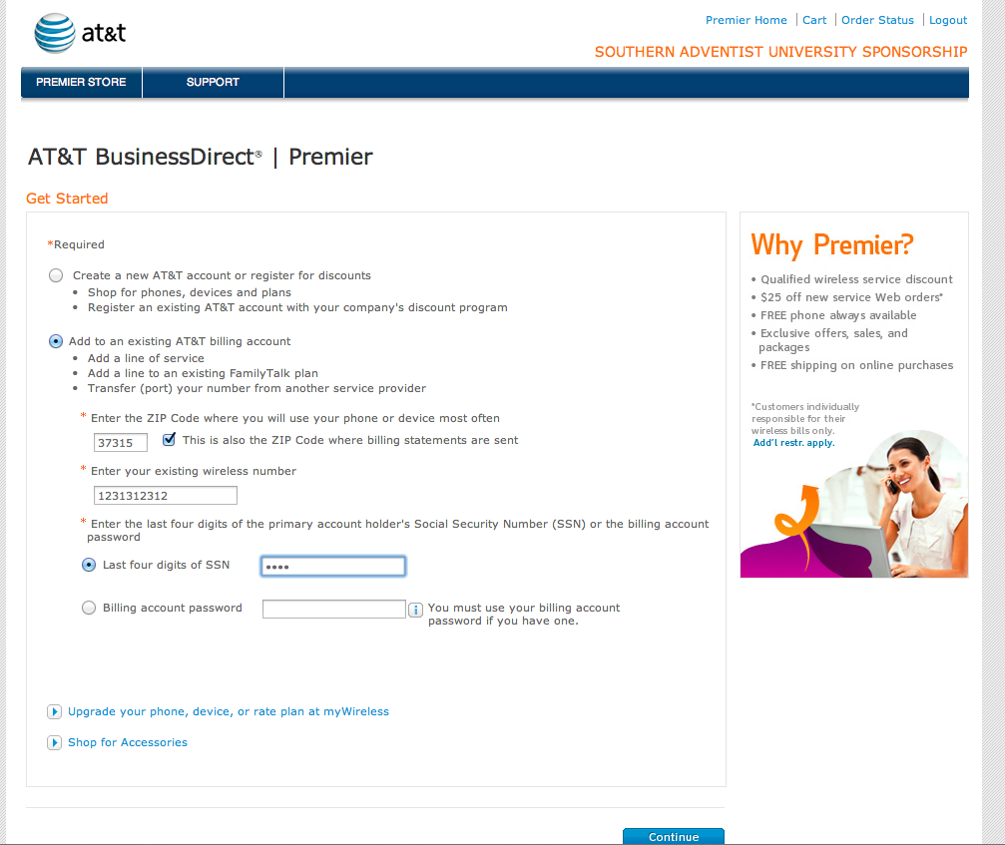

Step 4

When you get this error message, click on the “Online Validation Process” blue link.

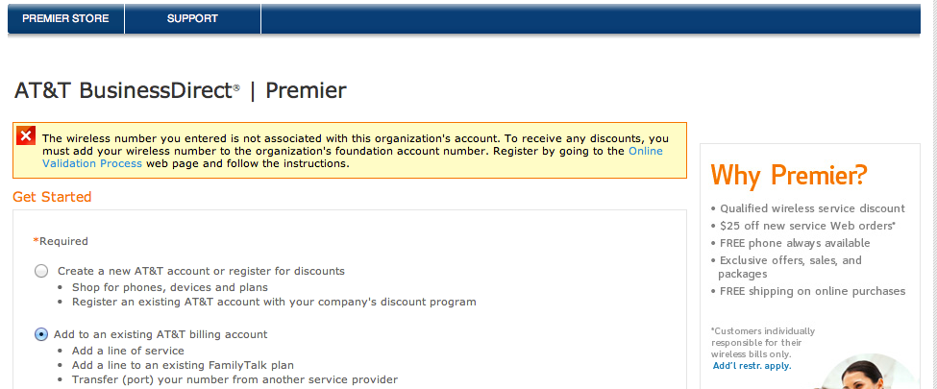

Step 5
Fill in the information

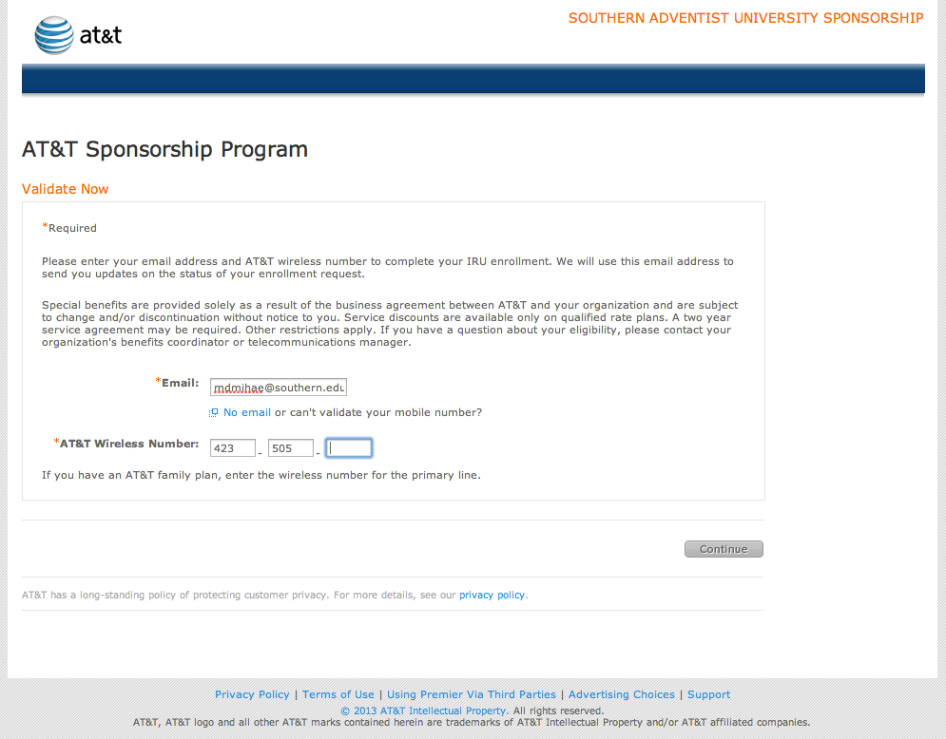

Step 6

Certify the affiliation with SAU by checking the box at the bottom of the screen on the.
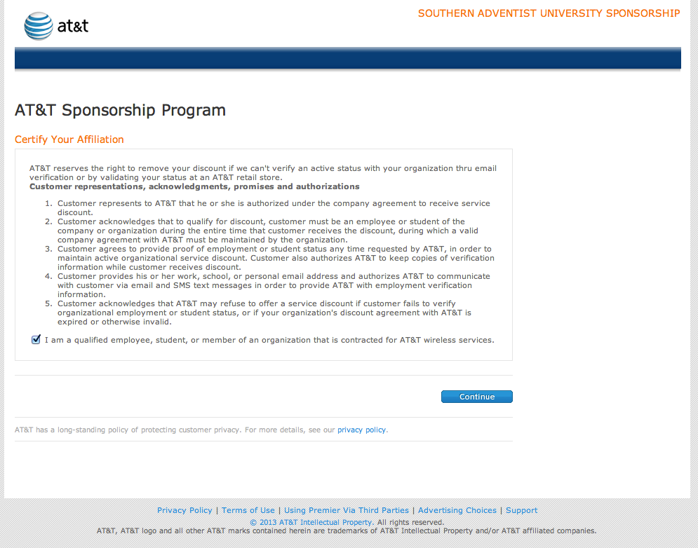

Step 7

You will receive the following “welcome” screen:

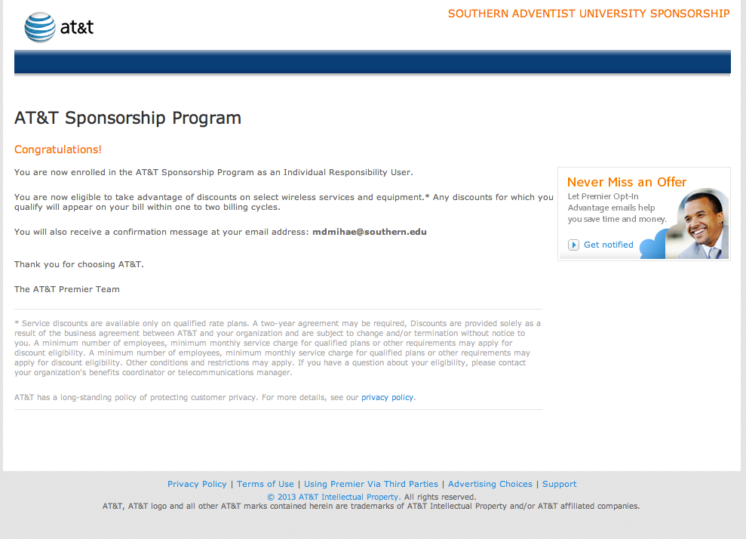

and you will receive an email that looks like this:

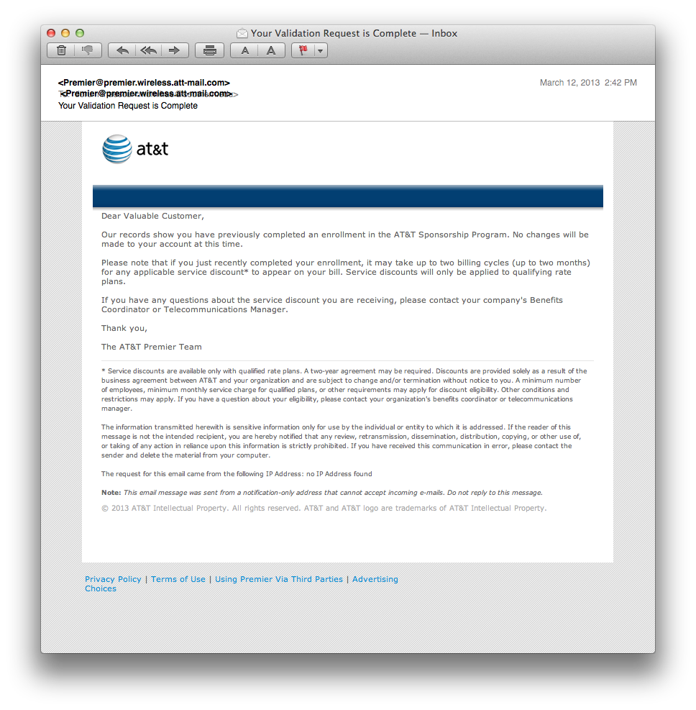

Final step

How to make sure you receive the employee discount. When you log into your att wireless account. You will notice the discount displayed in the upper left hand side.
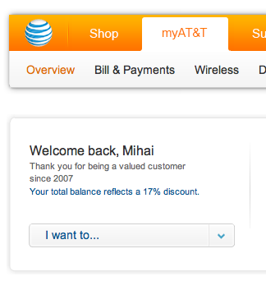

The discount may not show immediately as it may take up to 30 days to be registered in the system. To view the discount on the bill follow the instructions outlined below:
