Step 1

Go to www.verizonwireless.com/discounts under Check Your Eligibility type your @southern.edu email address and click “Check for Discounts”
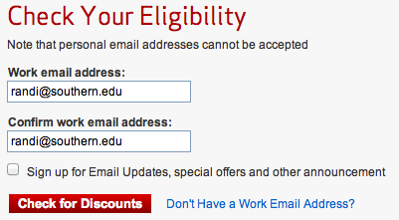

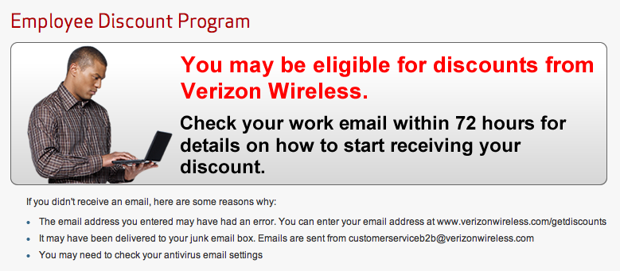

Step 2

You will receive a confirmation email. Please click on the “Register Your Line”
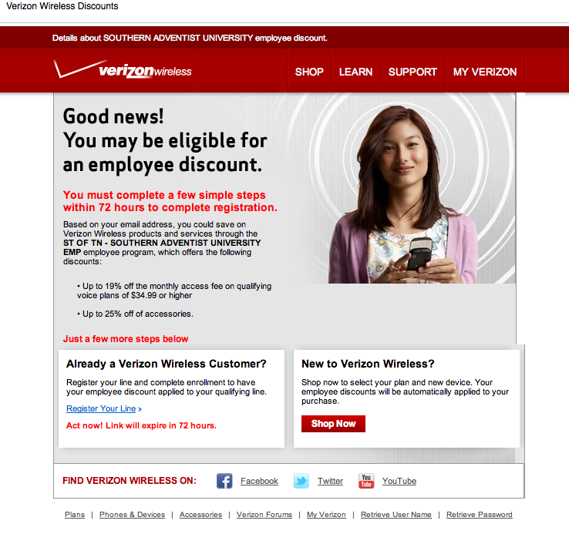

Step 3

Fill in the information displayed on the screen then click “continue”.

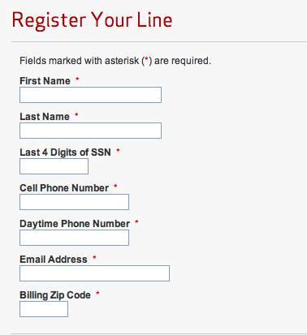

Step 4

Review your registration and click “continue”.

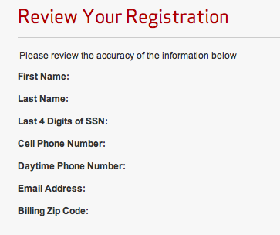

Step 5

Review Terms and Conditions, check “☑ I accept” and click “continue”.

