For use with any Geologic Column PowerPoints

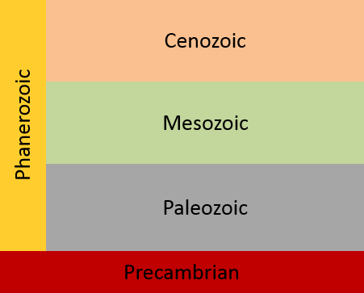

Print a copy for each student (could be laminated if you want to re-use them). Have students cut the layers apart and then practice putting them together to learn the names and arrangement of the layers.

Print a copy for each student (could be laminated if you want to re-use them). Have students cut the layers apart and then practice putting them together, recalling the names without prompting.

Print a copy for each student (could be laminated if you want to re-use them). Have students cut the layers apart and then practice putting them together, recalling the names without prompting or color.

