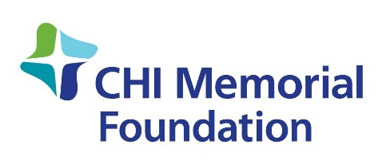

CHI Memorial Foundation
Intern Job Description

Purpose: To further the mission of CHI Memorial Foundation by assisting with fundraising events and development activities.

Duties and Responsibilities:
- Assist with all day to day activities of the Foundation’s fundraising related activity.
- Assist with the planning and logistics for Foundation Pink! Gala.
- Develop social media marketing, recruitment, and event updates for events including Facebook updates, tweets, and blog posts.
- Help manage participant and donor data in software programs.
- Attend and participate in event related activities and meetings including auction, sponsorship, sponsor party, Color Chattanooga Pink! and others as necessary.

General Requirements:
- Self-motivated, team player with the ability to meet deadlines, remain flexible, and adjust to changing priorities in a fast-paced environment.
- Strong organizational skills, with keen attention to details, as well as excellent problem solving abilities. Excellent oral and written communication skills.
- Moderate experience working with social media platforms (i.e. Facebook, Twitter).
- Have self-discipline and time management skills necessary to work independently.
- Proficient in Microsoft Office, specifically Word and Excel. Familiar with Google Workspace.
- Possess a valid driver’s license as well as the ability to travel as needed to perform internship duties.
- Currently be working towards a degree at a university, college, or trade school, in a related field.
- At least a sophomore class standing/ranking, with a minimum 3.0 GPA/4.0 scale.
- This internship is open to all majors; emphasis on Nonprofit Management, Fundraising, Event Planning, Business Administration, and Project Management.
- Physical requirements: Ability to stand and/or work on a computer for long periods of time; walk up and down stairs multiple times throughout the day; and lift at least 25 pounds.

Work Schedule/Time Commitment: Flexible schedule, approximately 10 to 15 hours/week, with exact days and times to be determined according to school schedule. Must be able to attend Pink Gala on January 22, 2022.

Stipend: $750 monthly (estimated depending on hours worked)

Responsible to: Foundation Event Planner

To apply for this internship, please send a cover letter and resume to Christine_willingham@memorial.org by September 24, 2021.

