EDCI 519 Online
HEALTH Methods (1 credit hour)
Summer 2023: Location:  Instructor:  Phone:  Office Hours:  Email: | Session 2: May 30th – July 16th  Online  Robert L. Overstreet  706.272.2345  M-Rh, 9 to 10 A.M., ET  robertoverstreet@southern.edu
Live Sessions: | Wednesday's on the following dates: June 6, June 13, and July 11 at 9:00 ET

Academic Online Support:

For Online Campus related questions, please contact:  Deanna Walker  Online Campus Advisor  Email: online@southern.edu  Office: 423.236.2087  Skype: lisahyder_3 | For course related questions, please contact:  Debra Maxwell  Online Coach  Email: debramaxwell@southern.edu  Skype: debramaxwell2
For technical or system support, please contact:
Greg Merchant, eClass Support Supervisor
Email: eclasshelp@southern.edu
Office: 423.236.2086
Skype: eclasshelp@southern.edu

System Requirements
For system requirements, visit this page: https://www.southern.edu/online/Pages/systemrequirements.aspx

Mission Statement
The Seventh-day Adventist Church recognizes teaching as a ministry and, therefore, an essential element in spreading the Gospel to the entire world. By fostering a growing relationship with Jesus Christ, our Creator and Redeemer, Seventh-day Adventist teachers have the privilege of leading and encouraging students on their journey toward wholeness. The online teacher certification courses are designed for professionals who teach in Seventh-day Adventist schools. The focus is to advance scholarship and innovative teaching and learning practices to meet the needs of today’s diverse learners. The courses will provide opportunity for collegiality, discussion of important issues, and collaboration while utilizing the best available technology to promote excellence in teaching and learning.

Learning Online
Technology is revolutionizing education. Computer-enhanced presentations, interactive instructional media, Internet-connected classrooms, Web-based courses, student chat-rooms and asynchronous discussions, streaming audio and video, satellite-distributed learning, and virtual universities are but indicators of profound changes sweeping the instructional landscape.
Utilizing interactive modes of instruction, the course focuses on preparing your heart and mind for furthering your ministry as a teacher. You are expected to participate actively in learning experiences through various technology media and prepare quality work. Basic competencies in word processing, Web browsing, email, and a compatible operating system are required as course entry points.
This course will employ the following instructional methodologies, among others:
- Weekly focus organized to praise, prepare, practice, ponder, and prove
- Select readings from scripture, Ellen White, and other experts
- Integration of core values into daily thought process
- Video lectures
- Web-based reference materials and resources
- Group discussion forums
- Live video conferencing sessions

COURSE ACCESS AND TEACHER CERTIFICATION INFORMATION
The website for course access is eclass.e.southern.edu. Here you will find an electronic version of the syllabus, descriptions of course activities and projects, and links to a variety of resources, including Southern Adventist University webmail, McKee Library, Campus Bookstore, and tutorials. This is also where you will access course grades. There are two ways that you can login to your online course. The course will appear as a link on your Southern Access account http://access.southern.edu. You can also put eclass.e.southern.edu into your browser and enter your username and password. If one method does not work, try the other method.
Accommodation for Disabilities. During short summer sessions, in keeping with university policy, any student who believes they may need an accommodation based on the impact of a disability or learning challenge should contact Disability Support Services at 423-236-2544 or stop by Lynn Wood Hall, room 1082 as soon as possible to arrange a confidential appointment with the Disability Services Director. Please note that accommodations are not retroactive and cannot be implemented until faculty or staff members have received the official Letter of Accommodation from DSS. Specific details of disabilities remain confidential between students and DSS unless a student chooses to disclose or there is legitimate academic need for disclosure, which is on a case-by-case basis. For further details, visit the Disability Support Services website at www.southern.edu/disabilitysupport. Students taking online courses from off-campus locations may also contact the DSS through email at dss@southern.edu.
Drops/Incompletes. If you should find that this course is too demanding of your time and you wish to drop, you MUST communicate with Lisa Hyder in the Online Campus office; she will help you through the process. Make sure that you receive confirmation from her that you have been officially dropped from the course. This is YOUR responsibility. In order to withdraw from a course it is NOT enough to stop logging in to eClass or to simply inform the instructor of your intention to withdraw. Failure to comply with this procedure may result in you receiving a failing grade. A grade of Incomplete (I) will only be given under extreme circumstances. Students must complete a written request for Incomplete before any extensions will be considered.
Tuition Refund. A student who drops a class will/will not receive a tuition refund based on the date he or she is officially dropped from the course. Consult the Undergraduate or Graduate Handbook for the semester dates by which you must drop a class in order to receive a tuition refund.
Important: Because the Summer sessions are condensed into a shorter period of time than the fall and winter semesters, the last day to drop a summer teacher certification course and receive a 100% refund is June 9, 2020.
Keeping in Touch. To facilitate communication between the instructor and learners, all class members are encouraged and expected to regularly check their southern.edu email account and the “News Forum” under the Course Resources within your eClass course. All eClass announcements posted to the class will be considered public class announcements.
Course Evaluation. Near the end of the semester each student will have an opportunity to evaluate the course. SAU requires all students enrolled in courses, on campus or on-line, to complete course evaluations as part of the ongoing process of improving course delivery and academic standards. All comments and evaluations are completely anonymous and the results of those course evaluations are made available to professors only after grades are submitted to the records office. A few minutes of your time and your honest feedback will assist your professor in shaping the course for future semesters and will provide academic administration additional information regarding the professor’s qualifications when his or her professional portfolio is reviewed.
You may access the evaluation at https://myaccess.southern.edu/apps/courseevaluation/

1. Log in using your SAU username and password.
2. Choose the professor and class you wish to evaluate from the list you see.
This evaluation will be used by the university to improve course delivery and academic standards. If you have problems with, or questions regarding this online course evaluation, please contact Monya Khan 423.236.2803 or mkhan@southern.edu.
Disclaimers. This course syllabus and attached schedule is subject to change at short notice. The instructor will endeavor to keep the changes minimal and communicate changes within the course site on eClass, but change may be necessary during the semester. Kindly be alert to announcements (either via eClass or via email) that may modify the syllabus or schedule. The subject material is often of such nature that there are many good approaches or answers. Therefore, although the instructor is educated and experienced, he/she does not know everything, nor does he/she have the answer to every question that may be asked. In addition, there will be subjects and issues on which he/she may have a biased viewpoint. However, the instructor will make every effort to indicate bias, and learners are free to agree or disagree.

UNIVERSITY STANDARD FOR WRITING
Southern has specific expectations for written work graduate level scholars. Although you will turn in your papers and other written assignments electronically, the correct mechanics of proper punctuation, sentence structure and paragraph organization is expected.
If this course is part of a graduate program you will be required to format your work according to the American Psychological Association’s (APA’s) style. If you are not familiar with that style, we have provided a helpful link https://owl.english.purdue.edu/

Academic Integrity/Ethics
Academic integrity is an integral part of the educational process. In this university setting, we seek to nurture independent thought and to maintain a professional and Christian code of ethics that upholds our own personal integrity and that of the academic community. Consequently, dishonesty of any kind is unacceptable and will result in a failing final grade for the course. If you are uncertain if a course of action is ethical, please refer to the Academic Honesty Policy that you will find at https://www.southern.edu/PublishingImages/academic_honesty.pdf.
Plagiarism Policy:
- Work that is submitted for credit must be the original work of the learner and specifically prepared for this course.
- Assignments that are not the original work of the learner are considered plagiarized and in violation of the honesty code.
- Plagiarism occurs when another person’s work, words, or ideas are represented as one’s own without the use of a school-recognized method of citation (e.g., copied from another source such as an author or another co-learner without properly acknowledging the actual writer/author).
- Plagiarism also occurs when knowingly giving or allowing one’s own work to be copied or otherwise duplicated by another for academic credit, or when resubmitting one’s own work for academic credit.
- Using any content from the Web without citing is plagiarism.
- The penalty for plagiarism may include a grade of F being recorded for the course.
In every eClass course you will see the following header and important links:
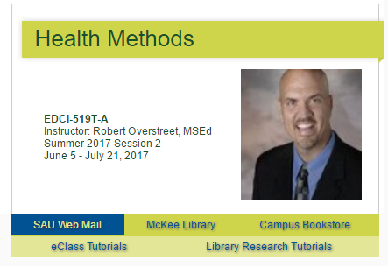
SAU Web Mail: This is a direct link to access your Southern email.
McKee Library Online: This is the online website for Southern’s McKee Library. This is your doorway to resources relating to your research and scholarly sources for your course work.
Campus Bookstore: This is a link to the Southern campus bookstore’s website where you can purchase books, collectibles and clothing with Southern’s logo.
eClass Tutorials: This is a link to a list of tutorials on how to navigate and use eClass. If this is the first course. If this is your first online course, make sure you review these tutorials before you begin the course work in these courses!
Library Research Tutorials: This is a link to tutorials on how to use the research material specific to McKee Library. If you are new to Southern and have not previously utilized the online materials at the McKee Library, make sure you review these tutorials before attempting to locate articles or information from a library database.
These links will remain at the top of every course to give you quick access to these very important resources.
Transcripts: It is your responsibility to request a transcript to be sent to your parent institution and/or your union registrar. You may access more information at https://www.southern.edu/records/transcripts/Pages/transcriptsoverview.aspx

Course Resources
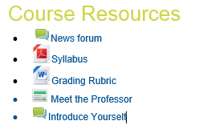
Just below the course header you will see several links that contain course content that does not attach to a specific week in the course. These are important resources you will access repeatedly through the course.
News forum: This forum contains announcements to the course from the professor. You will also receive a copy of these announcements to your Southern email.
Syllabus: This document is the heart of the course. It gives the outline for the entire course as well as course expectations and guidelines. Always refer back to this document if you have questions about the course.
Rubrics: These documents may or may not be present in all courses. They contain the grading rubrics for specific assignments through the course. If you have questions on the way a specific assignment is graded, refer to these documents.
Professor Introduction video: This is an introduction to the professor and his or her role in the course. Some course team.
Introduce Yourself: This forum is a place where you can learn about the other students in the course as well as give them a chance to learn about you.
This material may change per course and new material may be added to this section as the course progresses, so be sure to check back here often.

Weekly Content
As you scroll below the course header, you will notice that the course is broken down in topics PER WEEK. The current week will be highlighted in order to show you what material you will need to access immediately. You will see an icon based view that will break down the material for the week in an easy to navigate overview. You may click on the icons in any available week in the course to view content ahead, but the highlighted week will always be the current material. Your professor will determine when weekly content will become available. If the new week is not open by Sunday contact the online coach for your course.
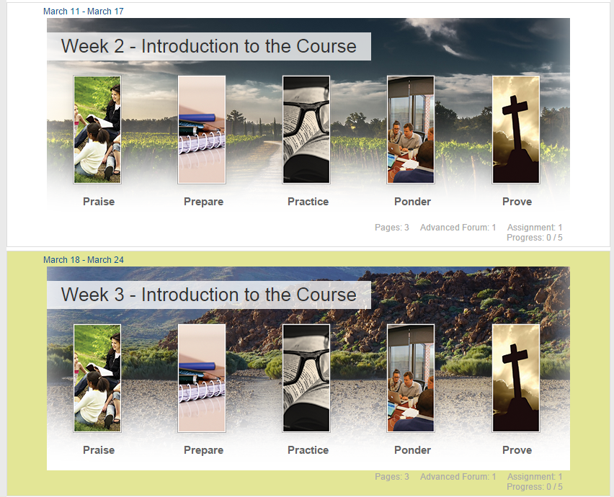

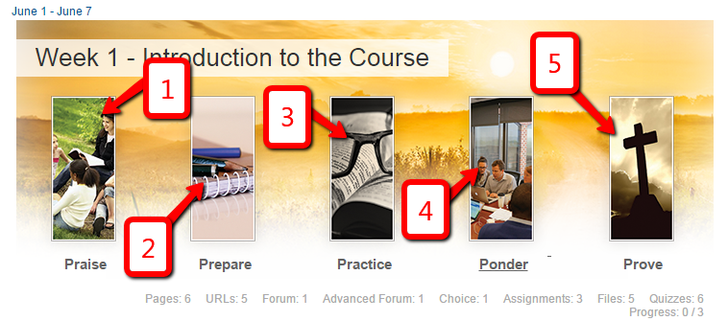
The icons across the top of the section represent the main segment of the material for the course. Click on each icon to review the content for the week. Be sure to read and review ALL the sections at the beginning of the week before you start work on any of the sections. A complete understanding of the week is critical.
- Praise: Contains the welcome and spiritual emphasis for the week, as well as the essential question and introduction to the week’s material.
- Prepare: Contains the readings for the week. These may include journal articles, book chapters, textbook readings, and media.
- Practice: Contains the main lecture material and instructor voice for the week. These are usually narrated PowerPoint or video lectures.
- Ponder: The Ponder section is the discussion forum where you will dialog with the professor and the other students in the course about the week’s material. Much of the learning in an online course happens in these forums, so don’t neglect this very important part of the program. Check daily for updates and don’t forget to post regularly.
- Prove: Contains the application of your learning for the week. This may be in the form of quizzes, interactive exercises, written reflection papers, research papers, or other proof of applied learning.

Grades
There are two places in eClass pertaining to grades. Both are located in the upper right hand corner of the course in “Settings” under “Course administration”.
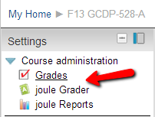
The two items you will need to access are:
Grades: This section contains the overview of the grades you have received so far in the course. The list of items and the points received for each item is provided here.
joule Grader: This section contains a detailed look at each item in the grade book. You can view the grading rubric as it was returned to you, along with any comments made in the rubric by the professor. You can also dialog with the professor about your grade. A list of all the posts you made in a graded discussion is also available in this location.

Grade symbols for this course
Grade | Percentage | GPA Points
A | 90% - 100% | 4.00
B | 80% - 89% | 3.00
C | 70% - 79% | 2.00
F | 0% - 69% | 0.00
To pass you must obtain a minimum overall of a C average in the course. Across the entire program, the minimum grade of C is permitted in no more than two courses.

COURSE GRADING AND POINT VALUES
Assignment Category | Total Points Possible
Week 1 Ponder | 25
Weeks 2 – 7 Ponder | 300
Weeks 1 – 7 Prove | 400
COURSE TOTAL | 725

Course Alignment with Professional Standards
Southern Adventist University
School of Education and Psychology
Professional Education Programs Conceptual Framework
To Serve, To Lead, To Transform
The Mission – School of Education & Psychology
The mission of the School of Education and Psychology at Southern Adventist University is to prepare effective Christian professionals who demonstrate a commitment to the pursuit of truth, wholeness, and a life of service in a diverse society.

The Goal – Professional Education Programs
The goal of the professional education unit is to facilitate the comprehensive development of school professionals as servant leaders in their communities.

This goal is reflected in the conceptual framework, in which we seek to provide opportunities for each candidate to become effective as: (a) a caring person, (b) an informed facilitator of learning, (c) a reflective decision maker, and (d) a committed professional. These core objectives are achieved through specific proficiencies that lay the foundation of professional excellence.

The Core Objectives and Expected Proficiencies
- As a caring person, the candidate/school professional will demonstrate knowledge, skills, and dispositions by:
  - Demonstrating an ideal of fairness and belief that all students can learn
  - Recognizing and respecting diversity, individual worth, and integrity
  - Considering the influence of community, school, and family context
  - Emulating the example of Christ-like service

- As an informed facilitator of learning, the candidate/school professional will demonstrate knowledge, skills, and dispositions by
  - Providing nurturing environments, services, and programs
  - Demonstrating understanding of central concepts
  - Demonstrating understanding of how individuals develop
  - Meeting the needs of a diverse student population
  - Using technology to enhance communication and student learning

- As a reflective decision-maker, the candidate/school professional will demonstrate knowledge, skills, and dispositions through
  - Demonstrating intellectual curiosity, critical thinking, and strategic decision-making
  - Using theory, based on scientific research, to enhance pedagogical and professional practice
  - Using formal and informal assessments to make informed professional decisions
  - Reflecting on professional practice

- As a committed professional, the candidate/school professional will demonstrate knowledge, skills, and dispositions by
  - Collaborating with peers and consulting with professionals
  - Demonstrating professional, legal, and ethical responsibilities
  - participating in opportunities to achieve professional excellence
  - Recognizing the value of health and a commitment to a lifestyle of wellness
  - Demonstrating appropriate communication skills

519 COURSE DESCRIPTION
This course is designed for Seventh-day Adventist in-service teachers. A study of the theoretical and scientific basis of health and wellness education with an emphasis on the development and organization of the school health instructional program through instruction and modelling. The course will focus on the Seventh-day Adventist health message as identified in the Bible and Spirit of Prophecy with applications in the classroom and beyond.

519 GOALS and Objectives

Upon successful completion of this course, the student will be familiar with:
1. EDCI519 will emphasize the awareness of the Seventh-day Adventist health message.
2. EDCI519 will emphasize the importance of meaningful and practical hands-on health related learning experiences.
3. EDCI519 will emphasize teaching health-related topics to a multi-grade classroom setting.
4. EDCI519 will focus on investigating, evaluating and refining health curriculum resources.

519 Course Assignments
We will have class meetings via Adobe Connect for weeks 3 – 6 held at 9:45 a.m. on Tuesdays. Your first meeting will be held on June 20th at 9:45 a.m. You are not required to use both a camera and microphone – either will suffice. Sign into the Adobe Connect class meeting room via this link: http://turner.southern.edu/edci519/ Contact your instructor in advance if you have scheduling conflicts. Sign into the Adobe meeting room as a guest with your first and last name – do not sign in with your username and password. Test your ability to access the meeting room before the first meeting, and contact eClass support at 423-236-2086 if you have trouble.
The grading system for this course is designed to assess your work from both a theoretical and practical perspective and covers a variety of assessments to measure performance toward achievement of the class goals and objectives. The grading scheme will reflect a total point system.
Submission Times and Late Work Caution. Course assignments are to be submitted electronically to the course site, unless specifically indicated otherwise. All assignments are due every Sunday at midnight (EST) or for international students, GMT plus 4 hours. Late work is at risk of not being accepted unless prior approval is received from your professor. It is your responsibility to plan ahead and to deliver a professional product in a timely manner. If, however, you are experiencing an unusual circumstance that is impeding your progress, please contact your professor immediately regarding the situation.
Participation in Class Discussions. You will interact with the other co-learners in class by posting original thought and replying to others’ posts. There is a minimum of one discussion that will be graded each week covering the essential question and topics for the week. To receive points and a grade you are expected to post a minimum of three posts (one initial post and two responses to classmates). You may respond as many times as you like, but you must meet at least the minimum of three quality posts. Your initial post is due Wednesday at midnight (EST) or GMT plus 4 hours. Your posts and participation each week, represents points that lead to your overall grade.
Assessments and Applications. Each week the Prove icon leads you to learning activities where you will apply what you have learned in various ways. It is essential that you read all of the materials provided for the week and watch any lectures provided. You are expected to incorporate the big ideas and understandings gleaned through the readings and lectures into the work you do in the course. Your timely submission of the assessments/activities/applications that you Prove each week represents points that lead to your overall grade. Your professor will determine the criteria and method for grading each exercise. Regular communication with your professor will help to ensure success. Check the weekly requirements in eClass for updates.

519 Selected Bibliography
Creation Health. Retrieved March 20, 2016, from https://www.floridahospital.com/events/creation-health-1
Desir, M. (2010). Curriculum-related trends in K-12 Adventist education in the North American Division: An inductive analysis of teacher perspectives as reported in the Profile surveys, 1987-2007. Andrews University, Berrien Springs, MI.
Gittens-St Juste, P. G., Nwosu, C. C., & McGarrell, F.-A. (2005). Profile 2004: What do we know about the quality and commitment of Adventist educators? Journal of Adventist Education, 68(1), 10-17.
Ruiz, A., & Brantley, P. S. (2001). Profile 2001: Results from the 8th biennial survey of Adventist educators. Journal of Adventist Education, 64(2).

518 textbook
No text is required.

519 Course SChedule

Date/Week | Praise | Prepare | Practice | Ponder | Prove
Week 1  Week of May 30th | “Do you not know that your bodies are temples of the Holy Spirit, who is in you, whom you have received from God? You are not your own” 1 Cor. 6:19. | Meet your teacher… VIDEO CLIP from ME  Meet and Greet Classmates/Professor (VIDEO LINK-MYSELF) | https://www.youtube.com/watch?v=RtOtI31QS6E  Watch this video clip from Creation Health and how it relates to your bodies being vessels. | Personal Introduction- Create a personal profile to be seen by your classmates.  Due: 6/14/20 at 11:59 PM | Draft a one-page vision statement that focuses on the concept or role as an Adventist teacher.  Due: 6/14/20 at 11:59 PM
Week 2  Week of  June 4th | Scripture tells us (we’ve probably memorized this text since we were young) that “We can do ALL things through Christ who give us strength” Philippians 4:13. How has God given you strength to overcome and claim victory? | Ministry of Healing: Chapter 9—Teaching and Healing Chapter 10—Helping the Tempted Chapter 11—Working for the Intemperate | •Access the NAD Standards for Health Sciences. Access the NAD Curriculum Guide for Health.  •Access the NAD Curriculum Guide for Elementary Science, Strand 5-Health.  The SDA Health Message:  •Read the SDA Summary Statement on Health | Examine the comparisons between CREATION HEALTH and NEWSTART.0020 Due: 6/14/17 at 11:59 PM | 1.Review CREATION HEALTH  2.Review NEWSTART  3.Compare CREATION to NEWSTART. What do they have in common? How do they differ? Be prepared to share your comparisons.  Due: 6/14/17 at 11:59 PM
Week 3  Week of  June 11th | Examine Mrs. Whites counsel about the importance of exercise  Health Principles | The Anderson Cooper 360 video highlights how “Adventists” live longer. | What does exercise look like? Is it mental or is it all physical?  •Utilizing this website; | Select one topic listed below and respond accordingly. Write a 2 paragraph response to each of the topics you selected. Due: 6/21/20 at 11:59 PM | •Application or gadget name/title  •CREATION Health theme it embraces  •How it can be used in the classroom to foster learning Health Due: 6/21/20 at 11:59 PM
Week 4  Week of  June 18th | Healthful Living, Page 60  Chapter 14—Causes of Disease | The website keepschoolssafeis a website that could help your school put together a health/readiness emergency plan. | Read “The Influence of Disease Upon the Mind and Morals” Chapter 12 Healthful Living – E.G. White  http://www.ellenwhitedefend.com/SOP-Library/Health/Healthful-Living.pdf | Identify two Biblical characters that were stricken with a disease.  Due: 06/22/20 at 11:59 PM | Select at least 12 references from peer reviewed journals that discuss strategies for teaching Health with at least two that focus on the topic of safety.  Due: 06/22/20 at 11:59 PM
Week 5  Week of  July 2nd | Unity plays an essential role in our everyday life. Acts of the Apostles – chapter 2 “Training of the 12” is a critical chapter on creating unity amongst believers. | Please read chapter 2 of Acts of the Apostles | Select one of the following topics and do a “google video search”  Heredity-Unity  Diversity | Topic A What can you do, as an Adventist Educator, what can you do within your classroom to promote diversity of your students?  Topic B How can you connect heredity or life origins to real life?  Due: 07/04/20 at 11:59 PM | Examine lifestyle plans such as “Creation Health”, “Daniel Diet”, “lifestylebenefits.com”, or “paradigmhealthplans.com”  Due: 07/04/20 at 11:59 PM
Week 6  Week of  July 9th | Select readings from Mrs. White that speaks on the topic of Emotions. | What lessons can be taught to our students about the value of family and community health? | Look at the standards for teaching health in the Adventist School system: NAD Standards for Health Sciences NAD Curriculum Guide for Health NAD Curriculum Guide for Elementary Science, Strand 5-Health. | Topic A What can you do, as an Adventist Educator, to promote “emotional health”?  Topic B What project could your classroom or school do on the topic of “community health”? 07/12/20 at 11:59 PM | When examining the role of the SDA School System, how does the term “Family” tie into what our schools are about?  07/12/20 at 11:59 PM
Week 7  Week of  July 16th | Daniel chapter 1 points out how special Daniel and his diet/choices led to his wisdom and stature. | Read “A Call to Stand Apart”, Mrs. White | The movie of “Daniel” depicts a visual representation of the life of Daniel. | Write a 2 paragraph response to the topic you selected. 07/21/17 at 7:00 P.M. ET | Select a section of Daniel’s life (In the Bible) and react to his dedicated lifestyle. 07/21/17 at 7:00 P.M. ET
Final Assignments Due July 20th

