Step 1

Go to www.sprint.com/verify

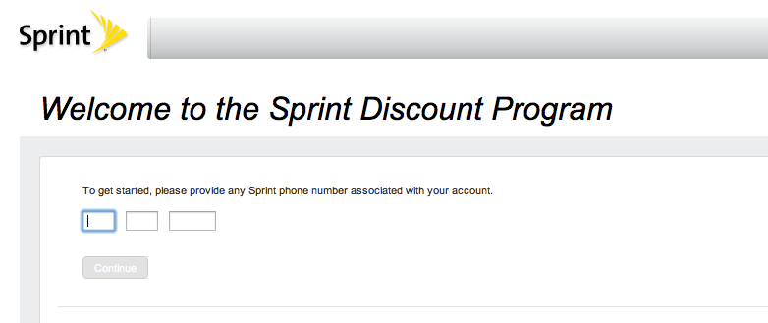

Step 2
Type in your cell phone number and click “Continue”
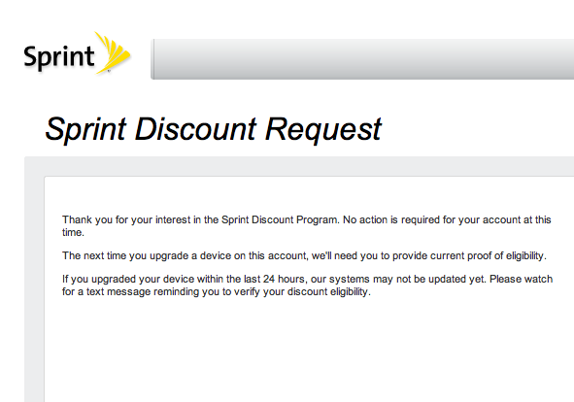

Step 3
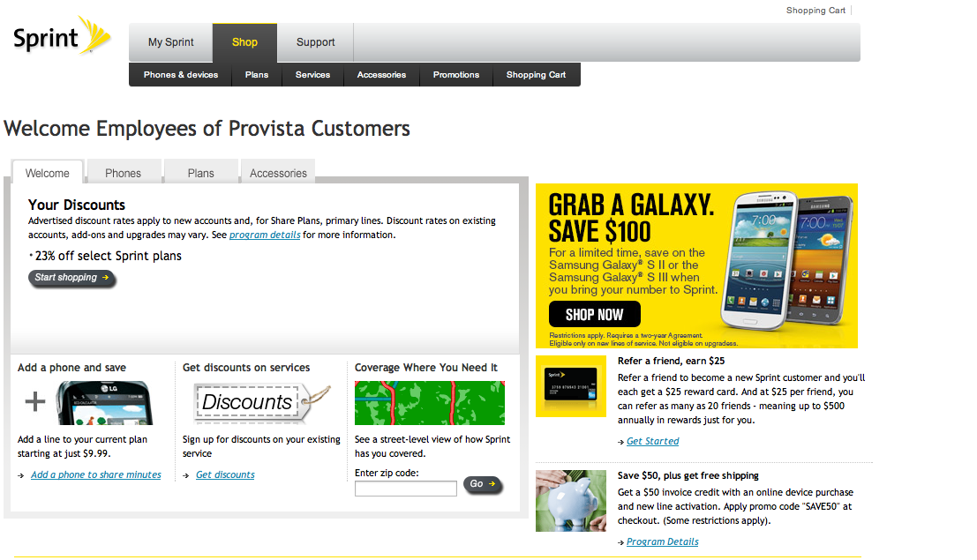

Employees of Provista Customers Private Store

Program Details
Your Discounts
- 23% off select Sprint plans

Shop Here And Save
www.sprint.com/provista

Discount rates advertised on this site apply to new accounts and, for Share Plans, primary lines. If a plan is eligible for a discount, the discounted monthly price will be shown. Discount rates on existing accounts, add-ons and upgrades may vary based on the discount available at the time service was established.
Take advantage of your company's purchasing power to receive discounted prices on select products and services. Simply purchase your phone, rate plan and accessories from this site. Your discount is already built into your price in this exclusive online store. Offer subject to a new two-year agreement, early termination fee and verification that line is eligible for discount under your company's service agreement.
Save $50 When You Buy Online Buy now and save! Get a $50 invoice credit when you apply promo code "SAVE50" to your cart at checkout! This offer is available only through this ordering portal. Sprint reserves the right to retire or extend this offer without further notice. A $25 invoice credit will be applied each month for two months for each eligible phone beginning on your second or third month's invoice depending on activation date and/or billing cycle. Offer requires activation of a new device and may not be available in all markets. For new orders with multiple devices on a Share Plan, the invoice credit will only apply to the primary line. $50 invoice credit is not available on iPhone purchases. Nor is it available on upgrades, replacements, add-a-phone to shared plan transactions or the following plans: All Simply Everything (SM) plans, All Basic plans, All Mobile Broadband Connection plans and All Desktop Modem Connection plans. Also, enjoy free shipping when you buy online. Sprint has a rate plan to suit your lifestyle Select from any number of plans with features such as free incoming calls, free weekends, free long distance, shared minutes and unlimited Nationwide Walkie-Talkie® calls, the two-way radio feature exclusively available to Sprint subscribers. Please review the Rate Plan details for additional information on the many plans available. Go Green! Sprint Wireless Recycling Wireless recycling is an important part of Sprint's environmental commitment. Our recycling programs were created to help prevent millions of phones from ending up in the waste stream. We encourage everyone to help preserve our earth for future generations by recycling their no longer used wireless phone through one our two programs. For complete details visit http://www.sprint.com/responsibility/communities_across/index.html. Sprint Buy Back Program The Sprint Buyback Program offers new and existing Sprint subscribers an account credit for hundreds of eligible wireless devices. We accept phones from ANY manufacturer and/or ANY carrier in ANY condition. For complete details visit www.sprintbuyback.com. Focus On Driving It can be tempting to make a call or send a text message on your mobile phone when you're driving to work, school or just running errands. During these moments, Sprint wants its customers and employees to remember that their primary responsibility when they're behind the wheel is to always focus on driving. Visit www.sprint.com/focusondriving to take Sprint's distracted driving pledge, and learn how you can become a more responsible driver and encourage others to do the same. Your Sprint Contacts To purchase by phone, or receive additional information on our products and services, visit the Support section for a list of resources ready to assist you. Conflicts Provision If you are a business customer and a conflict exists between the terms set forth in your agreement with Sprint and the terms set forth in this web site, the terms set forth in your agreement with Sprint controls. Learn More Now about Sprint Devices Click Here to learn more now. Sprint welcomes you to join our weekly online device trainings. Hosted by our national team of DSS Technical Trainers, we can help you learn more about the power of your Smartphone device. Mastering your smartphone or other wireless handheld device was never easier!

